**Face Recognition**

Prof Amogh D

Chinnapani Kiran Kumar

Parthavi Shastri

Introduction

The process of detection, alignment, feature extraction and a recognition are known as facial recognition. In recent years technology has been advanced bringing deep learning in light which is a subfield of machine learning that is concerned with algorithms inspired by the structure and function of the brain called **artificial neural networks.** Since 2014, the deep learning has reshaped the research landscape of facial recognition.

To study and apply deep learning concepts in facial recognition we used 21 Celebrity pictures dataset from Kaggle.

Brief

# The model used is Convolutional Neural Networks (CNN). It is a type of neural network model which allows to extract higher representations for the image content.7 layers are been used with softmax as activation function. ****Activation functions**** are a critical part of the design of a neural network.

# The interface we created is using streamlit app. Streamlit is an open-source Python library that makes it easy to create and share beautiful, custom web apps for machine learning and data science.

# Steps to follow while using streamlit web interface:

# Step 1: Click on the Browse files button.

# Step 2: After clicking the browse button a dialog box appears. It allows you to import image from local images.

# 

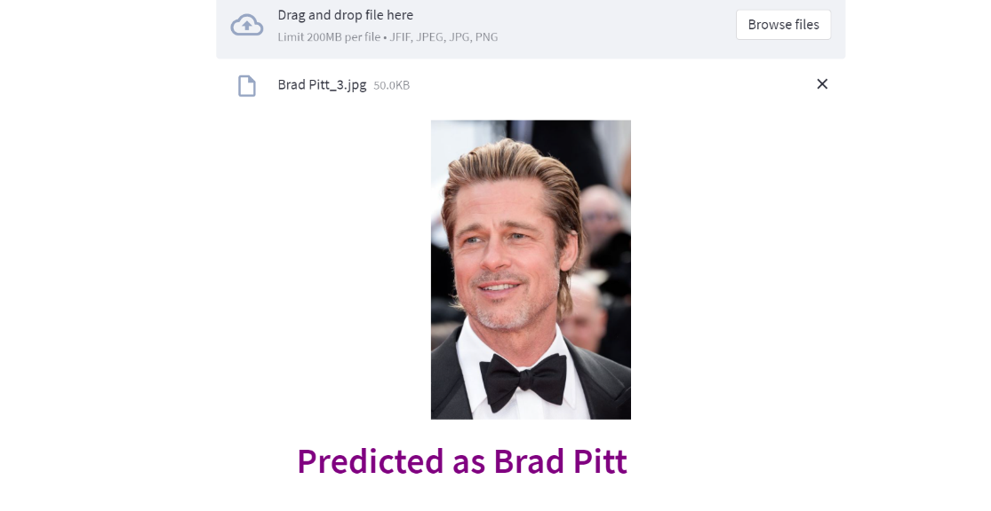Step 3: After uploading the image from local images. The output looks like: